ROJECT DEVELOPMENT PHASE

**SPRINT - 1**

|  |  |
| --- | --- |
| DATE | 17 NOVEMBER 2022 |
| TEAM ID | PNT2022TMID05066 |
| PROJECT NAME | SMART FASHION RECOMMENDER APPLICATION |

Login, signup and home page UI designs

HTML CODE:

INITIAL SETUP:

<!doctype html>

|  |
| --- |
| <html lang="en"> |
| <head> |
| <meta charset="utf-8"> |
| <title>SmartFashionRecommender</title> |
| <base href="/">  <meta name="viewport" content="width=device-width, initial-scale=1"> |
| <link rel="icon" type="image/x-icon" href="/assets/logo.png"> |
| <link rel="stylesheet" |
| href="https://fonts.googleapis.com/css2?family=Material+Symbols+Outline |
| d:opsz,wght,FILL,GRAD@20..48,100..700,0..1,-50..200" /> |
| <link rel="preconnect" href="https://fonts.googleapis.com">  <link rel="preconnect" href="https://fonts.gstatic.com" crossorigin> |
| <link |
| href=["https://fonts.g](https://fonts.googleapis.com/css2?family=Cinzel%2BDecorative%3Awght%407)o[ogleapis.com/css2?family=Cinzel+Decorative:wght@7](https://fonts.googleapis.com/css2?family=Cinzel%2BDecorative%3Awght%407) |
| 00&family=Tangerine:wght@700&display=swap" |
| rel="stylesheet"> |
| </head> |
| <body> |
| <app-root></app-root> |
| </body> |

</html>

LOGIN PAGE

|  |
| --- |
| <section class="container-fluid h-100 login-container"> |
| <div class="row h-100 justify-content-center align-items-center"> |
| <div class="col-12 col-md-6 d-none d-md-block"></div> |
| <div class="col-12 d-flex justify-content-center col-md-6"> |
| <div class="login-form-container p-3"> |
| <h2 class="mb-4 login-text"><img class="login-logo-img" |
| src="/assets/logo.png" alt="logo">Login</h2>  <div> |
| <div> |
| <input type="tel" class="login-input" |
| placeholder="Mobile number"> |
| </div> |
| <div> |
| <input type="password" class="login-input"  placeholder="password"> |
| </div> |
| <p class="text-center" style="font-size: 10px;"> |
| By login, you agree to our Terms of Use and |
| Privacy Policy. |
| </p> |
| <div class="text-center">  <button class="primary-btn" |
| routerLink="/">Login</button> |
| </div> |
| <!-- new account --> |
| <p class="text-center mt-3">New to Fashion <a |
| routerLink="/signup" |
| class="text-decoration-none">Create an  account</a></p> |
| </div> |
| </div> |
| </div> |
| </div> |
| </section> |

SIGNUP CODE:

|  |
| --- |
| <section class="container-fluid h-100 login-container">  <div class="row h-100 justify-content-center align-items-center"> |
| <div class="col-12 col-md-6 d-none d-md-block"></div> |
| <div class="col-12 d-flex justify-content-center col-md-6"> |
| <div class="login-form-container p-3"> |
| <h2 class="mb-4 login-text"><img class="login-logo-img" |
| src="/assets/logo.png" alt="logo">Sign up</h2> |
| <div> |
| <div>  <input type="email" class="login-input" |
| placeholder="Email"> |
| </div> |
| <div> |
| <input type="text" class="login-input" |
| placeholder="User name"> |
| </div>  <div> |
| <input type="tel" class="login-input" |
| placeholder="Mobile number"> |
| </div> |
| <div> |
| <input type="password" class="login-input" |
| placeholder="password">  </div> |
| <p class="text-center" style="font-size: 10px;"> |
| By signup, you agree to our Terms of Use and |
| Privacy Policy. |
| </p> |
| <div class="text-center"> |
| <button class="primary-btn" routerLink="/">Sign  up</button> |
| </div> |
| <!-- new account --> |
| <p class="text-center mt-3">Existing User <a |
| routerLink="/login" |
| class="text-decoration-none">Login</a></p> |
| </div>  </div> |
| </div> |

|  |
| --- |
| </div> |
| </section> |

|  |
| --- |
| /* You can add global styles to this file, and also import other style |
| files */ |
| :root { |

--primary-color: #b0e6dc;

LOGIN , SIGNUP CSS:

|  |
| --- |
| --secondary-color: #c0c2c3; |
| } |
| html, body { |
| height: 100%;  margin: 0; |
| } |
| .cursor-pointer { |
| cursor: pointer; |
| } |
| /* button styles */ |
| .primary-btn { background- color: black; |
| color: white; |
| border: 0; |
| padding: 0.7rem 2.5rem; |
| border-radius: 10px; |
| } |
| .secondary-btn { |
| background-color: white; |
| color: black; |
| border: 1px solid black; |
| padding: 0.7rem 2.5rem; |
| border-radius: 10px; |
| } |
| // login screen and signup screen |
| .login-container { |
| background-image: url("/assets/login-banner.png"); |
| background-repeat: no-repeat; |

|  |
| --- |
| background-size: cover; |
| }  .login-text { |
| font-family: "Cinzel Decorative"; |
| letter-spacing: 0.7rem; |
| } |
| .login-logo-img { |
| width: 4rem; |
| height: 4rem;  } |
| .login-form-container { |
| background: rgba(255, 255, 255, 0.2); |
| border-radius: 16px; |
| box-shadow: 0 4px 30px rgba(0, 0, 0, 0.1); |
| backdrop-filter: blur(5px); |
| -webkit-backdrop-filter: blur(5px); border: 1px solid rgba(255, 255, 255, 0.3); |
| } |
| .login-input { |
| background: rgba(255, 255, 255, 0.2); |
| border-radius: 16px; |
| box-shadow: 0 4px 30px rgba(0, 0, 0, 0.1);  border: 1px solid rgba(255, 255, 255, 0.3); |
| margin: 1rem 0; |
| padding: 0 1rem; |
| height: 3rem; |
| width: 25rem; |
| } |
| @media only screen and (max-width: "600px") { |

.login-input { width: 100%;

}

}

HOME PAGE CODE:

|  |
| --- |
| <section class="container-fluid"> |
| <div class="row align-items-center main-con" |
| style="background-color: #b0e6dc;"> |
| <div class="col-12 col-md-6 py-4"> |
| <p class="banner-text">Make your |
| </p>  <p class="banner-text">fashion more |
| </p> |
| <p class="banner-text d-flex align-items-center"> |
| <span class="material-symbols-outlined" |
| style="font-size: 5rem;"> |
| chip_extraction |
| </span><span>perfect</span>  </p> |
| <div> |

|  |
| --- |
| <button class="primary-btn shop-btn" |
| routerLink="/products">Shop Now</button> |
| </div> |
| </div>  <div class="col-12 col-md-6 text-center"> |
| <img class="w-75 h-75" src="/assets/landing-banner.png" |
| alt="Landing Banner"> |
| </div> |
| </div> |
| <!-- landing icons sections -->  <div class="row justify-content-center main-con shadow"> |
| <div class="col-12 col-md-3 py-2 py-md-4 d-flex |
| align-items-center border-end border-bottom"> |
| <div> |

|  |
| --- |
| <span class="material-symbols-outlined land-icon"> |
| chat |
| </span>  </div> |
| <div class="ms-4"> |
| <p class="fw-bold mb-0">CHAT BOT</p> |
| <span>A smart way of finding products</span> |
| </div> |
| </div> |
| <div class="col-12 col-md-3 py-2 py-md-4 d-flex  align-items-center border-end border-bottom"> |
| <div> |
| <span class="material-symbols-outlined land-icon"> |
| rotate_90_degrees_ccw |
| </span> |
| </div> |
| <div class="ms-4">  <p class="fw-bold mb-0">30 DAYS RETURN</p> |
| <span>Simply return within 30 days</span> |
| </div> |
| </div> |
| <div class="col-12 col-md-3 py-2 py-md-4 d-flex |
| align-items-center border-bottom"> |
| <div>  <span class="material-symbols-outlined land-icon"> |
| monetization_on |
| </span> |
| </div> |
| <div class="ms-4"> |
| <p class="fw-bold mb-0">100% PAYMENT SECURE</p> |
| <span>Best payment gatway</span> |
| </div>  </div> |
| </div> |
| </section> |
| <section class="container-fluid"> |
| <div class="row"> |
| <div class="d-flex justify-content-between"> |

|  |
| --- |
| <h2> TRENDING ITEMS </h2>  <p class="text-end"><a routerLink="/products" |
| class="text-decoration-none">See all ></a> </p> |
| </div> |
| <div class="col-12 p-md-5"> |
| <app-product-card |
| [product]="productDatails"></app-product-card> |
| </div>  </div> |
| </section> |

OUTPUT SCREENS: LOGIN SCREEN

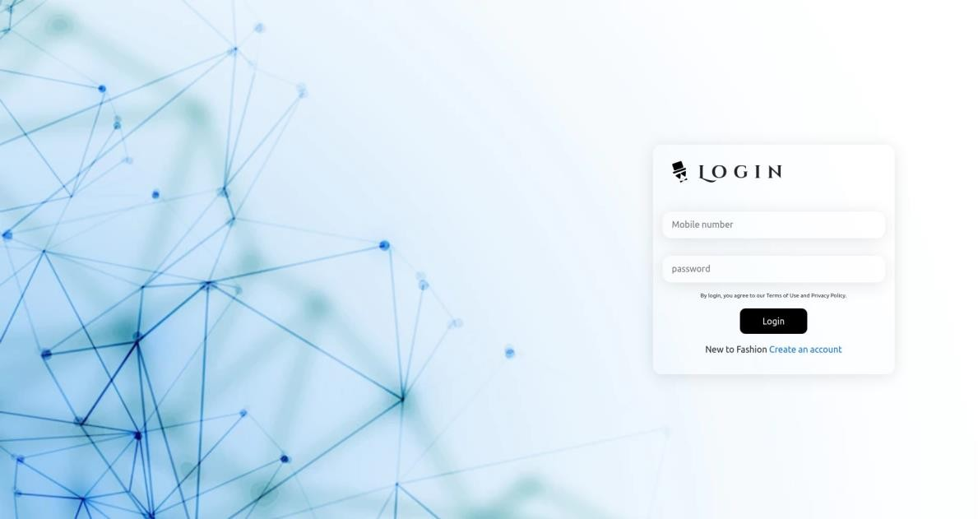

SIGNUP SCREEN

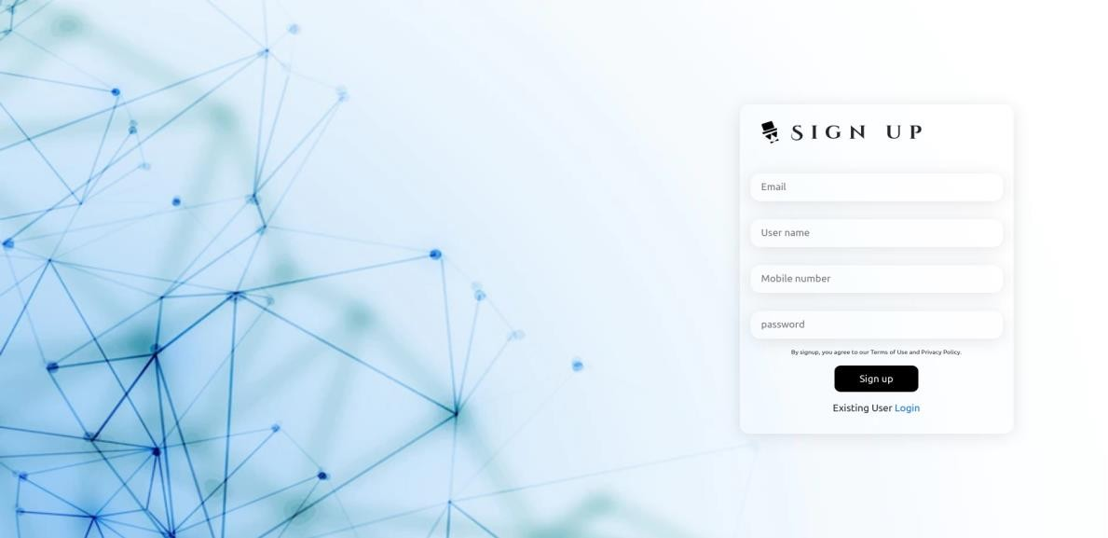

HOME PAGE

